Applying Behavioural Insights to the Early Years: A Toolkit
Randomisation guide

Introduction

This guide walks you through how to randomise your data in Excel. Use it with the Excel version of the guide. You can also find a short video walkthrough guide on the toolkit website.

The example we'll use here is a fictional study exploring whether changing the wording of a letter can increase the number of parents applying for the 2 year old free childcare offer. The steps would be similar when you run your own study.

Step one: Review a randomised list

Have a look at the ‘randomisation example’ tab in the Excel guide. This shows you what a full randomised dataset looks like.

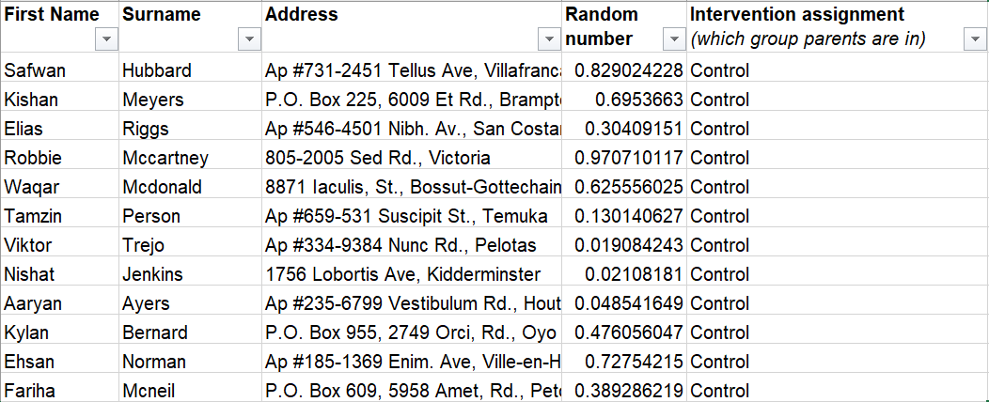

Step two: Generate your random numbers

First, go to the ‘Randomisation practice’ tab. This is to practice on a dummy list before doing it on your own. You’ll see a list of 100 fake parents.

In order to randomly assign recipients into two groups, we will use Excel’s rand() function to generate a random number for each row.

Go to the “Random number column”. On the following row, type the following command:
=rand()

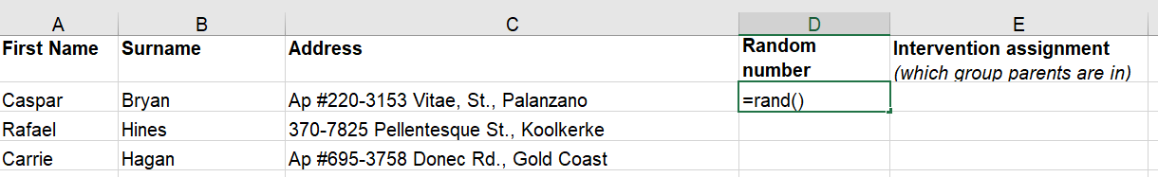
After pressing Enter, you will see that a number between 0 and 1 is randomly generated. Now, fill this command down the entire column to assign a random number for each of the rows. You can do so by dragging the fill handle down to the final row.
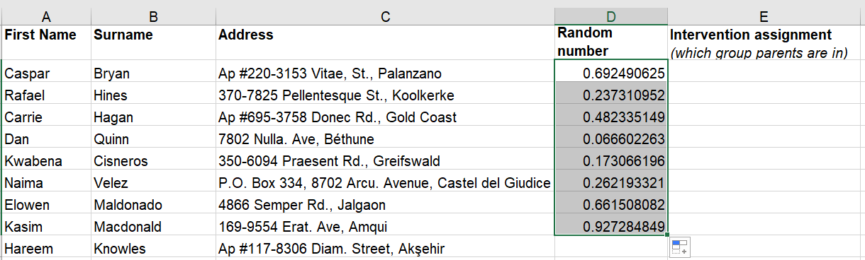

Next, copy and paste the whole random number column in exactly the same position it was
previously in. Make sure to select “paste as values” when pasting. This fixes the numbers and stops them from changing every time you edit the spreadsheet (the rand() command does this automatically).

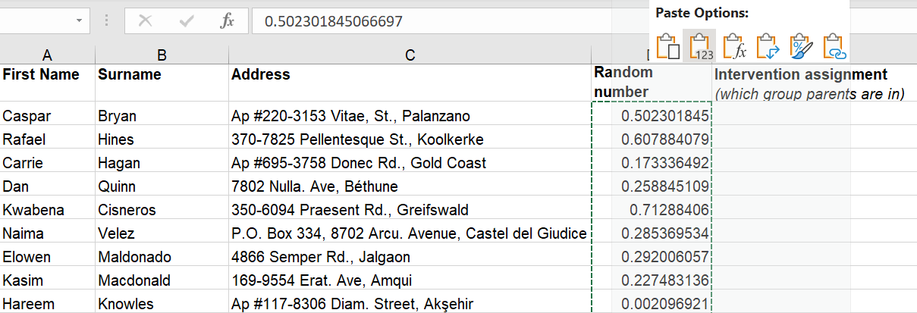

Step three: Sort your dataset
Now we sort the entire dataset. You can do this by (1) selecting all your data, (2) clicking the ‘Data’ tab at the top of your screen, and (3) clicking the ‘Filter’ button.

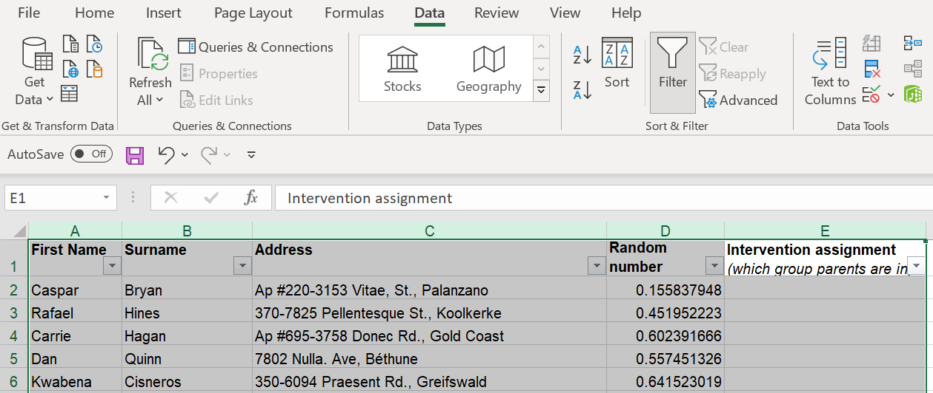

A small dropdown arrow should appear on each column heading. Click on the arrow on the ‘Random number’ column and select ‘Sort smallest to largest’.

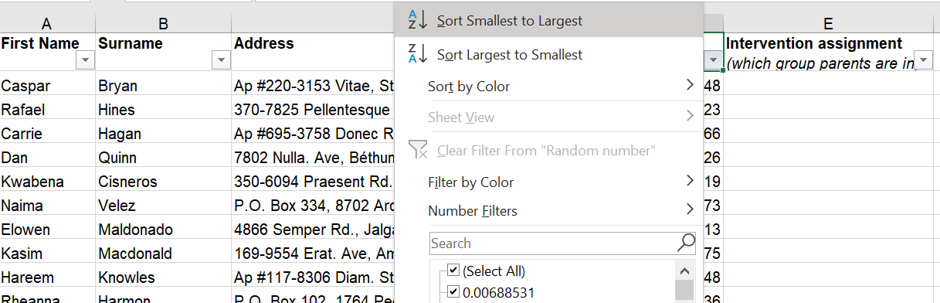
Once you click on “Sort Smallest to Largest”, the order of the rows will change so that the random numbers for each row are in ascending order.

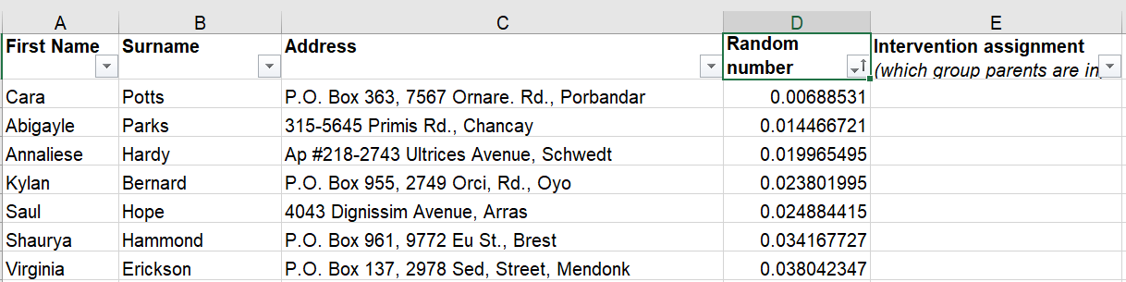
Now we’re ready to assign parents to groups. Go to the column called “Intervention assignment”. Type in “Control” to the first half of the rows and “Intervention” to the second half of the rows. You can use the same drag method that you used to generate the random numbers.

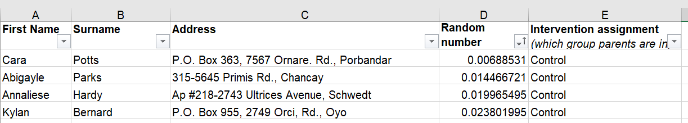

That’s it! You have randomised your practice dataset and can move on to the real thing.

Step four: Randomise your own dataset

Now it’s time to randomise your own dataset.
You can do this by either:
- Copy and pasting your data into the ‘randomise your data’ tab of the Excel guide, or
- Following the instructions above in your own spreadsheet.

