Thinking about money in new ways: Social Investment

This paper offers an introduction to the field of social investment. It analyses how social investment works; provides a typology of different forms of social investment; an account of how a reasonably comprehensive set of investment funds and tools has grown up in the UK; analysis of the potential of new tools such as Social Impact Bonds; and describes some of the key challenges, such as scale, returns and evidence. In a field full of hype, it seeks to provide a more realistic overview to help practitioners, including investors, likely recipients of investment and policy makers.



A Brief History:

The mobilisation of finance for social purposes is not new. Socially-oriented investment institutions and funds are common in much of the developed world – notably in Catholic countries (Italy has a clutch of Church-related banks – a tradition that gave birth to Banca Etica and Banca Prossima more recently); Germany has its regional small business banks, Spain has many regional and cooperative banks, some with very overt social goals like Caja Laboral in the Basque country. Crédit Coopératif in France, Triodos Bank in the Netherlands and Belgium, Charity Bank in the UK and hundreds of state-owned banks across the world have all had more or less overt social missions, often to spread wealth to poorer regions and to create jobs.

The promise:

Successful investors were confident that the investment methods which had served them so well in business could be usefully applied to social problems.

So how should we understand what social investment is, and what it could be? The essential shape of the field is easy to describe. All types of social investment connect:

There are at least eight very different types of social investment whose differences arguably outweigh their similarities:

**4. Finance for other types of social organisation – charities, mutuals etc – usually in the form of loans**

**2. Commercial investment in firms with some social or environmental objectives as well as financial ones (most ‘impact investment’ in the US is of this kind).**

**1. Commercial investment to serve low income markets (the ‘bottom of the pyramid’).**

**3. Investment in social enterprises – either equity or loans.**

**5. Savings vehicles for the public which promise social outcomes as well as financial returns (and are then invested in 1-4 above)**

**6. Direct provision of personal finance for socially excluded individuals and families (credit, mortgages etc)**

**7. Procurement of social outputs and outcomes by governments and sometimes foundations**

**8. Finance for high risk social innovation**

INTERMEDIARIES:

who connect providers and users, and may be able to improve the effectiveness with which capital can be used (through knowledge, skills, networks), all supported by…

ENVIRONMENT:

(of law, regulation, tax incentives &c) which enables alignment of the motivations and rewards of each group.

PROVIDERS:

of capital motivated to achieve both financial and social returns in varying mixes

USERS:

of capital, who can deploy it in ways that will achieve financial revenues and social impacts, linked by ….

The UK experience – evolving an ecosystem of social investment:

The UK arguably now has one of the world’s most evolved policy environments for social investment. Government tried to align three types of intervention to achieve a coherent policy for social investment:

* Creating enabling conditions
* Enabling funding
* Enabling demand



A comprehensive ecology of investment:

With these providing an enabling environment, the detailed challenge was to put in place forms of finance for every stage of the evolution of social projects and ventures, from the very high risk early stage, to finance to support growth or takeovers. These overlap substantially but broadly rise in scale with equivalent reductions in risk. The diagram below summarises these, and the subsequent bullet points provide a rough hierarchy of types of finance:

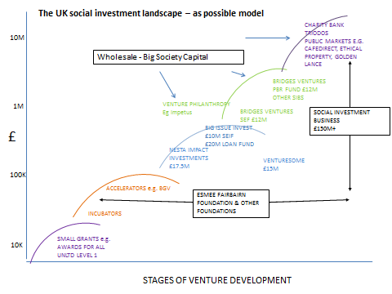

The following types of investment cover the different stages of development of ventures. Some of the social investment models don’t fit so neatly into this framework – in particular ones providing products for the public (such as credit unions). But the aim of ensuring that there is finance available at each stage is a reasonable goal for any country.

* Proof of concept funding – often provided by foundations at a slightly higher level (eg £10-40k) to help innovators demonstrate their idea in a real world environment. For example, Esmee Fairbairn Foundation provides finance at this stage as well as operating in several of the categories listed below.

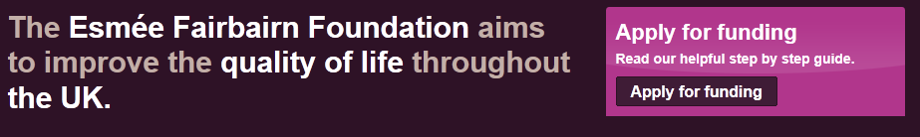

* Very early stage finance - Awards for All, UnLtd, providing small grants of between £500 to £10,000 to thousands of individuals with, in theory, very few strings attached.

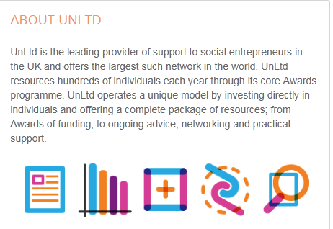

* Accelerators – these ‘start up factories’ have become common in technology business, supporting cohorts of start-ups with intensive support, initially under £20k, but are now spreading into the social field. Bethnal Green Ventures is a good example in the UK.



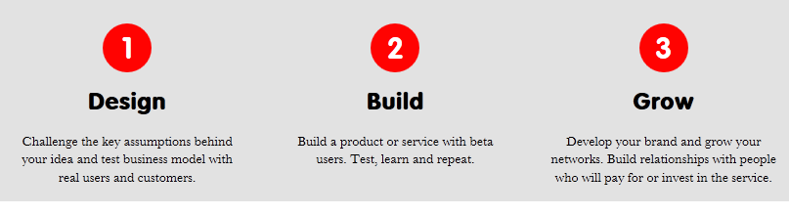

• Social and living labs – a related approach has been the spread of Living Labs which test new ideas, often from NGOs, in real life conditions. The Global Living Labs network links many of these. Others include incubators such as Social Innovation Generation @MaRS in Toronto, Young Foundation in London or DenokInn Social Innovation Park in Bilbao.

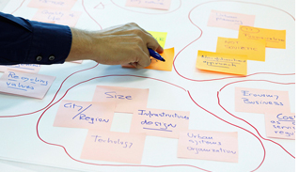[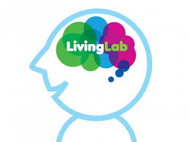](http://www.google.co.uk/imgres?biw=1067&bih=713&tbm=isch&tbnid=b0NGo1lbC9F6aM:&imgrefurl=http://nadiachiudesign.com/?portfolio=living-lab&docid=-87GvvyNE3jThM&imgurl=http://nadiachiudesign.com/wp-content/uploads/2013/01/livinglab_logo-480x359.jpg&w=480&h=359&ei=RUAHU-u9NMjB7Abr-IGQAQ&zoom=1&ved=0CLoBEIQcMB8&iact=rc&dur=637&page=3&start=28&ndsp=18)

• Early stage investment funds. A stage on from these are the various early stage loans and equity funds such as Venturesome, Impetus Trust and the Department of Health’s Social Investment Fund and the Scottish Social Investment Fund. These tend to fund more established ventures rather than innovations.

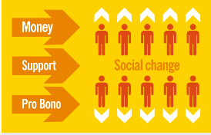

• Finance first funds. At a somewhat larger scale there are commercial investment funds which prioritise financial return while also aiming to achieve social impact, also known as ‘finance first’ investors. These include Bridges Ventures in the UK, PhiTrust in France and BonVenture in Germany.



• Social investment funds are quite similar, but prioritise social impact while also seeking a financial return for their investors or in order to ‘recycle’ funds into new investments. These are also known as ‘impact first’ investors. These include CAF Venturesome, The Big Issue Invest and Social Investment Business intheUK,thHellenicSocialInvestment Fund in Greece, Fondazione CRT in Italy.

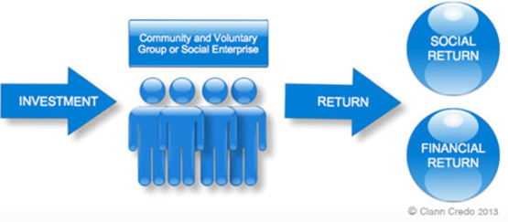

• Venture philanthropy funds remain relatively small and aim to combine grants with intensive engagement. Examples include Impetus Trust and Private equity Foundation (now merged) and the Social Business Trust and the d.o.b. foundation in the Netherlands.

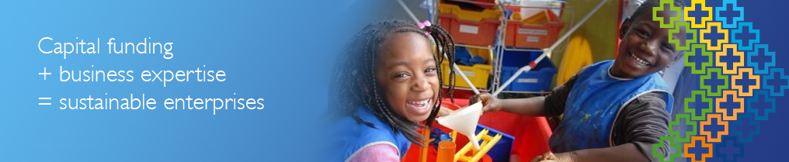

• Innovation funds: These are public funds explicitly focused on innovation, combining grants, loans and equity. Many are primarily focused on technology such as the Technology Strategy Board in the UK, SITRA in Finland and Vinnova in Sweden, but they are increasingly engaging in social issues and working with NGOs. The NHS Regional Innovation Funds in the UK were a good recent example, mainly focused on service innovations.



• Social banks – such as Triodos and Charity Bank providing larger tranches of loan finance, and often taking deposits.

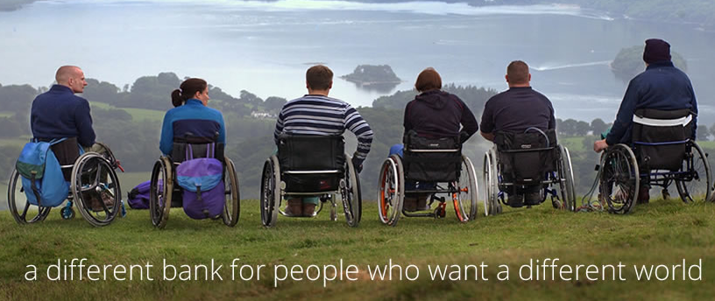

• Public offerings – these are issues of bonds and other vehicles by large charities and social enterprises, such as Café Direct, Ethical property and Golden Lance.



• Wholesale and intermediary funding – the best example is Big Society Capital, which was capitalised with around £600m, partly from unclaimed bank accounts and partly from a deal with the major retail banks. On a smaller scale the US Social Innovation Fund also aimed to mainly fund intermediaries.

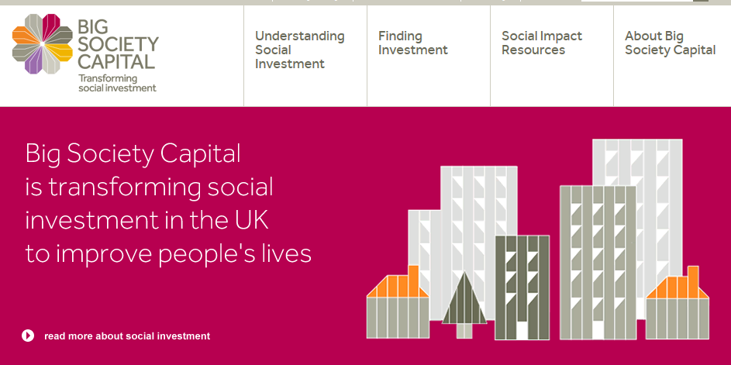

• Loans linked to contracts. These are funds explicitly designed to provide working capital for NGOs signing up to contracts with pay-by-results.



Procuring Outcomes

Social Impact Bonds

There is extensive evidence on potential paybacks to investment in early years programmes, or preventive measures in crime or health. But turning these into propositions for investment has proved hard. Incentives are misaligned: those who have the ability to improve social outcomes lack the incentive to act.

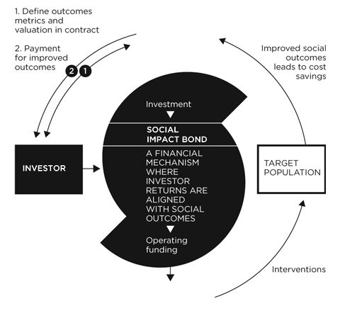

Social Impact Bonds are one of the possible tools for achieving more for less. Work on their design and implementation has been in train since early 2008, when the City Leader’s Group began work to identify new types of investment vehicles for social outcomes (the term Social Impact Bond was devised as a snappier alternative to ‘contingent revenue bonds’, and various other terms have been used around the world, including ‘pay for success bonds’ and ‘social benefit bonds’ ). Some of this work was taken forward by a new organisation called Social Finance, which agreed the first SIB in the final days of the UK Labour government in early 2010.

Social Impact Bonds, Pay for Success, and a new family of preventive investment tools, some using municipal borrowing

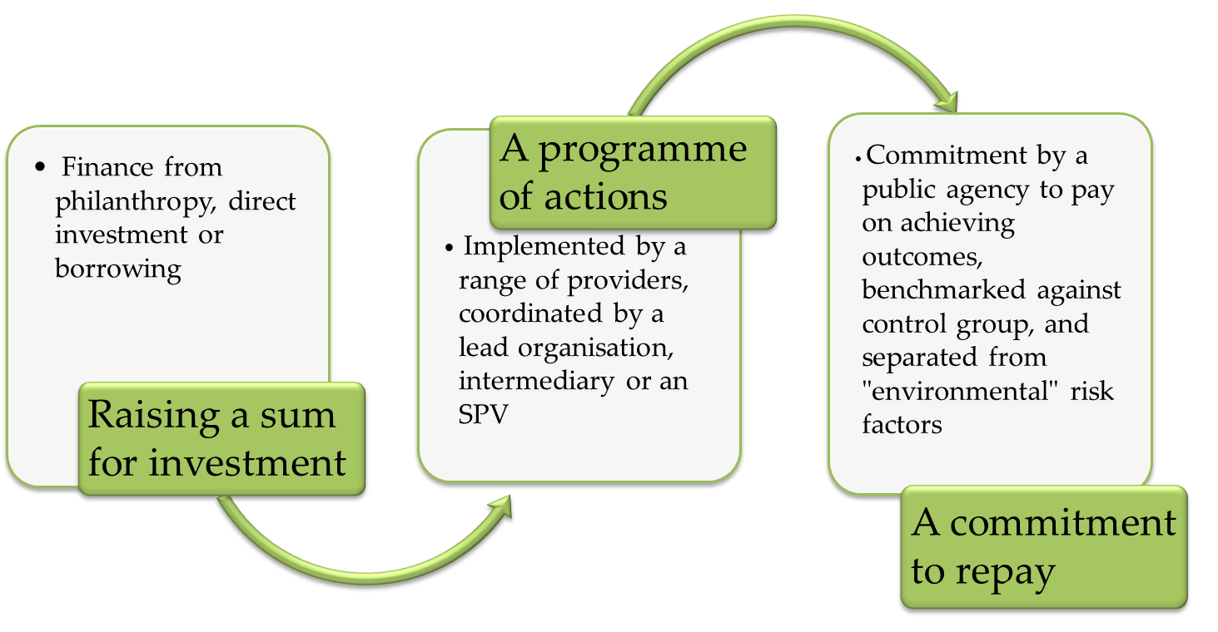

In Summary:

Returns: Some social purpose businesses can achieve good returns, as can many social enterprises. But most NGOs struggle to achieve even very modest returns, and may be unwise to take on debt finance. Genuine innovation is bound to be risky and requires suitable finance, with the right mix of grant funding and investment.

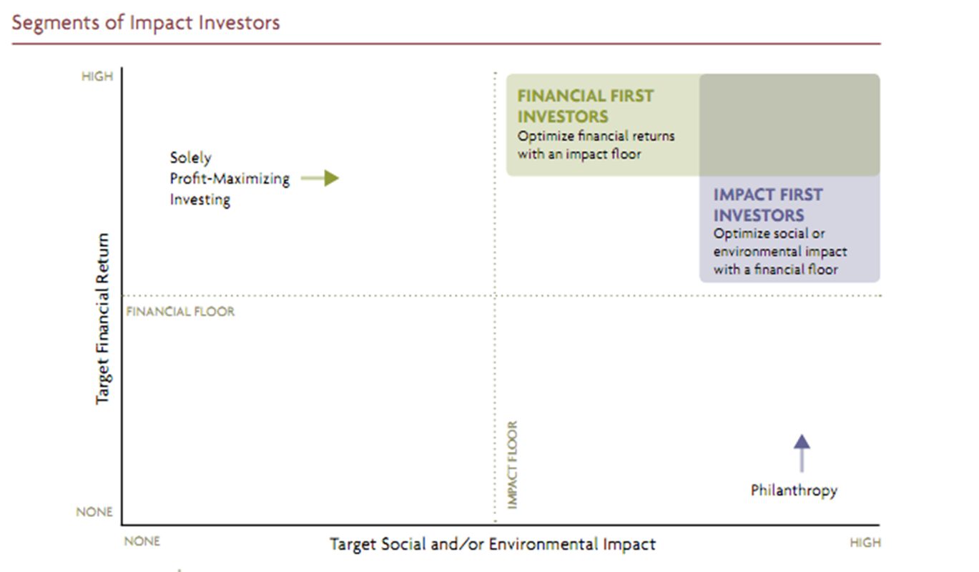

Definition. As already pointed out, the field suffers from blurred boundaries and confused labels.



Impact. There has been huge effort devoted to better understanding and measuring impact, and linking this to investment.

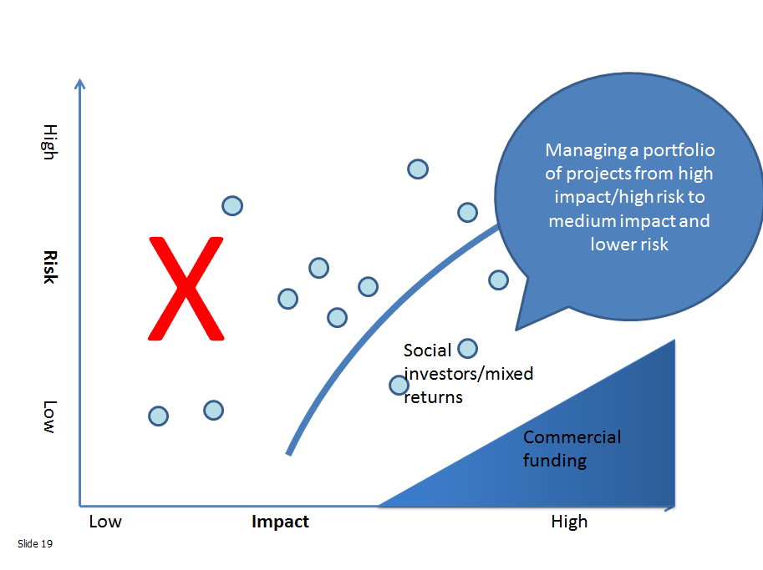

Deep craft. The most developed fields of innovation benefit from a ‘deep craft’ – people building up experience in how to fit things together, what works, and how to turn ideas into reality.



Scale. One of the main arguments for social investment is that it will enable great social ideas to grow big. Currently only a tiny proportion of NGOs grow big, far fewer proportionately than in business.. Most civic organisations find scale difficult and, although there are some very large NGOs, such as the Red Cross or Caritas in Germany, most are small. Some of this has to do with lack of capital or skills, but there is also a legitimate fear that greater scale can corrode values, commitment and intimacy.

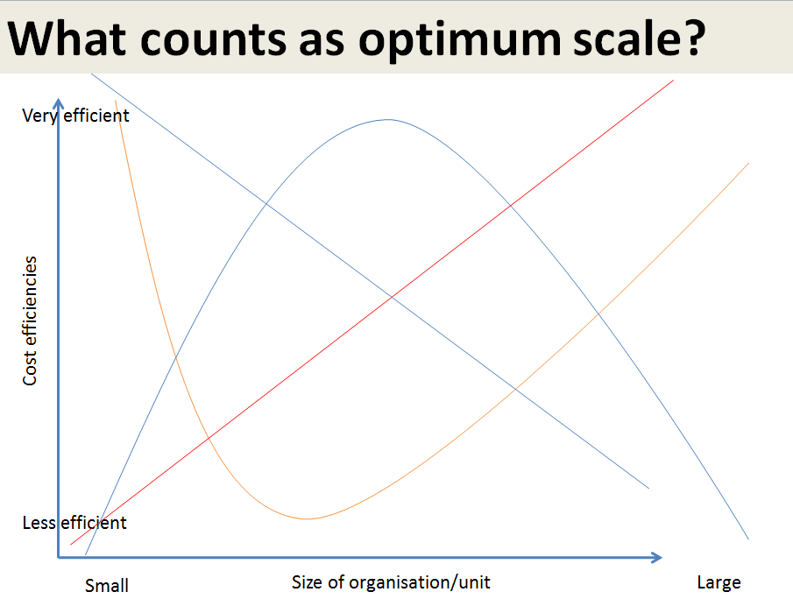

Where next?

One of the main promises of social investment is to bring greater clarity about what works – and to redirect resources to more effective approaches. Nesta has developed a way of being systematic about evidence, with the aim is to achieve a common language for describing the strength of evidence around particular interventions. This five step ladder integrates many similar models developed around the world.

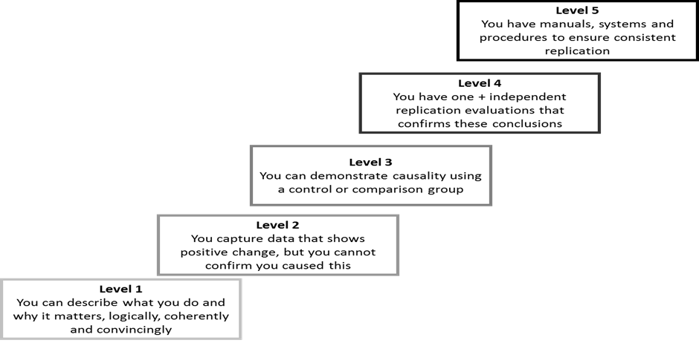

The social investment field now has plenty of momentum. The G8 has committees and action groups. The EU has held large events and launched the social business initiative. But the main priority for the field is to develop more practical examples of social investment; to better understand what achieves returns, with low transactions costs; to learn fast from increasingly global experience; and to grow the craft skills.

